**Automate a Web Application**

**1.Automated Employee Registration form:**

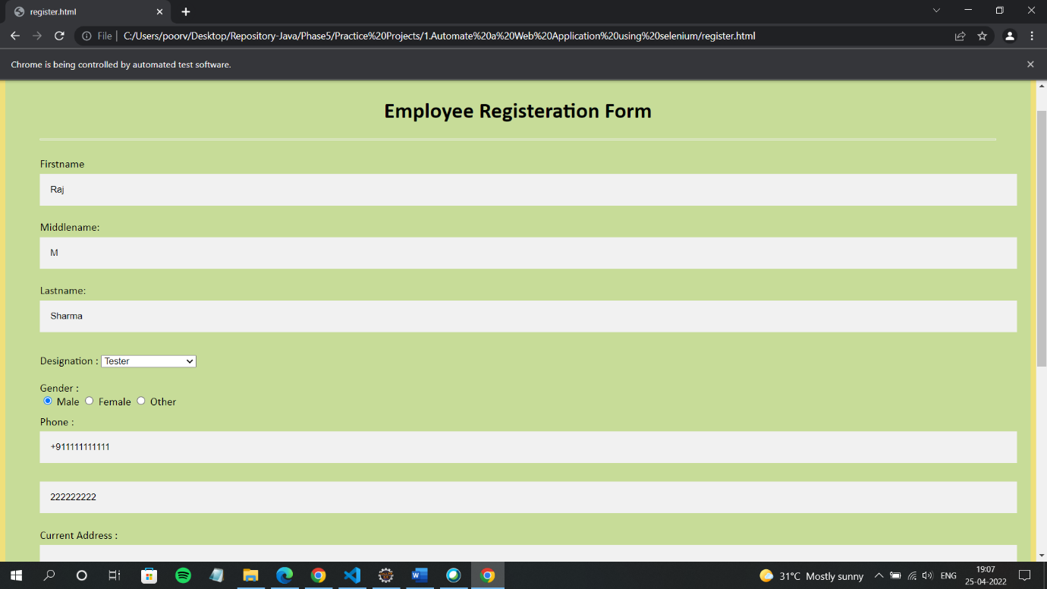

**2.code**

